Status of Argo Bulgaria, 1st March 2012

The Bulgarian Argo activity is carried out in the frames of the BulArgo “Development of national research infrastructure as a component of Argo network” project, financed by the Bulgarian National Science Fund. It comprises a consortium of three scientific organizations: Institute of Oceanology in Varna, Sofia University “St. Kliment Ohridski” and National Institute of Meteorology and Hydrology in Sofia. The focus of the ongoing research program is the monitoring of the Black Sea.

- The status of implementation

The first time Bulgaria took part in the Argo activities was in December 2009, when one French PROVOR float (#5902291) was deployed in the deep part of the Black Sea during the cruise of R/V Akademik. This vessel is operated by the Institute of Oceanology in Varna. Further, in March 2011, three APEX floats (#6900803, 6900804, 6900805) were deployed in the Black Sea by the scientific team of the project on board of the R/V Akademik. The floats were purchased from the BulArgo project and one of the floats was equipped by an oxygen sensor. Currently, the data are available at the Institute of Oceanology website (http://www.gisserver.io-bas.bg/Web_argo).

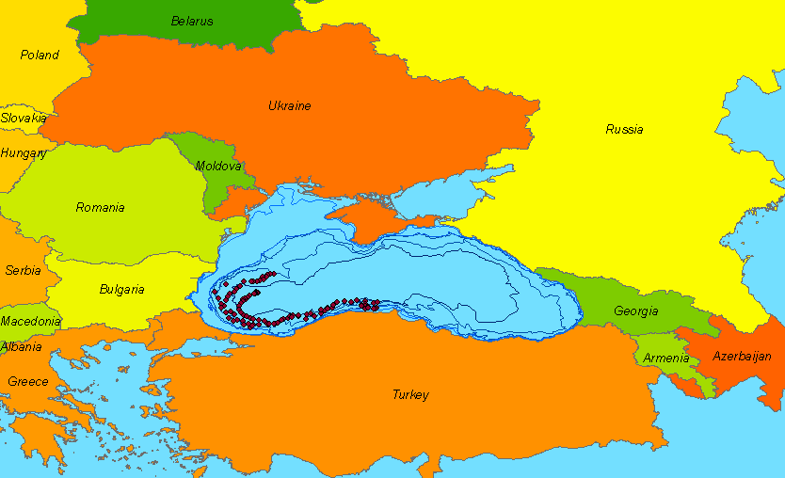

Figure. Locations of the 3 BulArgo floats measurements since 18 March 2011.

Delayed mode

At present the standard procedures for real time and delayed mode data processing and quality control are performed at the French Argo Data Centre Coriolis. However, the procedures are being revised by the competent staff to account for the Black Sea regional characteristics

- Present level of and future prospects for national funding for Argo

BulArgo project covers the period 2010-2012 and it is financed by the Bulgarian National Science Fund initially with 200 kEuro. Unfortunately due to the financial crisis the overall sum was decreased by 40% for the second half of the project. Thus four floats in total will be deployed in the Black Sea in the frame of this activity. The logistics will be provided by the Institute of Oceanology in Varna. The BulArgo project comprises a consortium of three research organizations: Institute of Oceanology in Varna, University of Sofia “St. Kliment Ohridski” and National Institute of Meteorology and Hydrology in Sofia

Extensive collaboration with the Bulgarian Ministry of Education, Youth and Science during the Euro-Argo preparation phase project has lead to an agreement at ministerial level that Bulgaria joins the Euro-Argo ERIC as a full member, thus a support for the membership fee and the deployment of 3 floats per year in the Black Sea has been ensured.

- Summary of deployment plans
Bulgarian activities focus on the Black Sea. In December 2009, in the frame of a collaborative effort with France, Bulgaria deployed one PROVOR float (#5902291) in the deep part of the Black Sea, providing support and logistics during the cruise of R/V Akademik, organized by the Institute of Oceanology in Varna. After the beginning of the BulArgo project, in March 2011 three APEX floats (#6900803, 6900804, 6900805) were deployed in the Black Sea. This activity was performed by the researchers in the project on board of the R/V Akademik. Apart from the standard CTD measurements, one of the floats was equipped by an oxygen sensor.

Float deployment in 2012 will follow the national plans in the frame of BulArgo (one float). Additional deployment is foreseen of four floats provided by the OGS-Italy. Deployments activities (three deployments altogether) are expected to start in the spring of 2012 and will continue until fall 2012.

Additionally, BulArgo will further establish infrastructures together with the Black Sea regional partners, and substantial enhancement of this activity is expected to happen if the submitted regional infrastructure project (Black Sea Argo) is accepterd. In the the frame of this two years project 10 floats are planed. Further activities will
be organized in the E-AIMS if accepted.

- Data management
The data from the floats deployed under the BulArgo project are available at the Institute of Oceanology website (http://www.gisserver.io-bas.bg/Web_argo). The standard procedures for real time data processing and quality control are performed at the French Argo Data Centre (www.coriolis.eu.org). Collaboration with the scientists at MedArgo data center is ongoing to allow for processing data also in MedArgo. At the moment the data quality procedures are being revised by the competent staff to account for the Black Sea regional characteristics.

- Summary of national research and operational uses of Argo data

The key objectives to use the Argo data in the Black Sea involve:
- Development of adequate data quality control procedures taking into account the Black Sea peculiarities
- Study or the changes in the temperature and salinity near the surface and the deep layers
- Assimilation of the Argo data in a Black Sea circulation model
- Evaluation of chemical properties
- Quantification of the steric effects in the Black Sea
- Getting new insights about the deep circulation of the Black Sea
- The use of the data for educational purposes at the university.

- Issues we wish to be considered and resolved
The influence of the aggressive compounds on the float functioning

