Status of Argo Norway, 1st March 2012

The Norwegian Argo programme is carried out by the Institute of Marine Research (IMR) (http://www.imr.no/) as part of their environmental monitoring activities. The Norwegian Argo programme focus on the Nordic Seas regarding climate monitoring and research and seek to include users with focus on the ecosystem monitoring and research. Float deployment are done with IMR’s research ships and often in collaboration with the German Argo. The Institute of Marine Research (IMR) is involved in the international Argo programme with contribution of Argo floats, ship time for deployment and user of the data. At present, IMR is the only institution in the Argo Norway.

- The status of implementation

At present we have in total purchased and deployed 15 floats, all in the Norwegian Sea. Three floats were deployed in 2002, six floats in 2003, two floats in 2006 that included oxygen and fluorescence sensors, and four floats in 2010 that also included oxygen and fluorescence sensors. All floats are APEX floats and the latest four deployed floats have Iridium telemetry. At present only three of our floats are active.

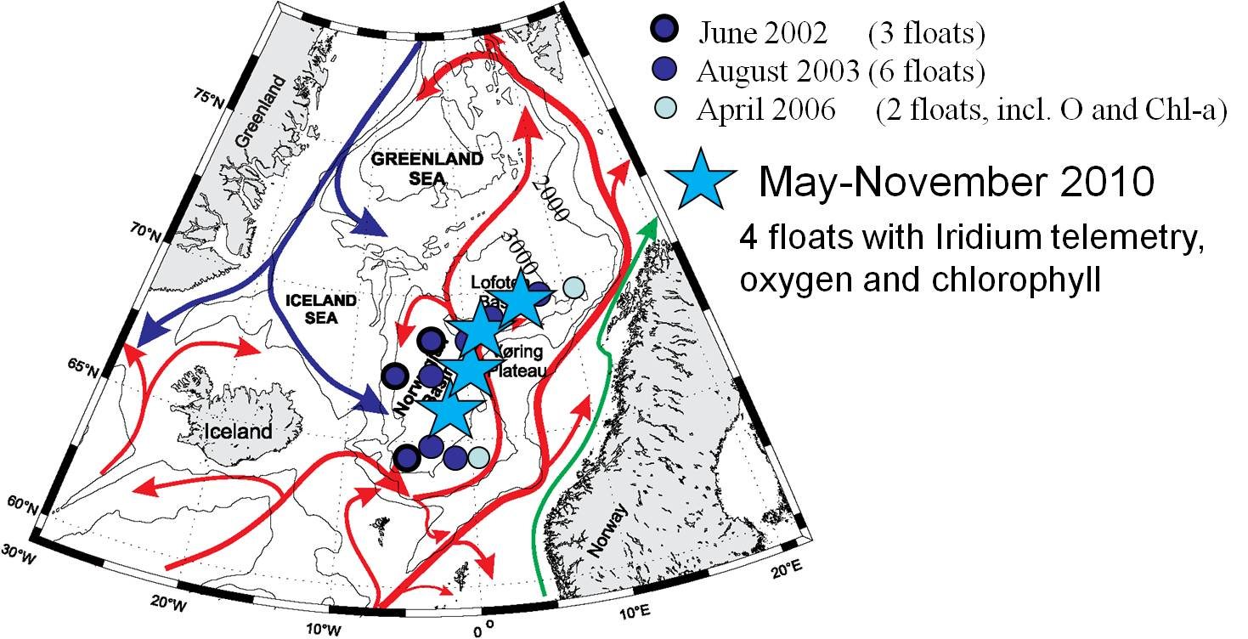

Figure. Locations of all Argo deployments from Argo Norway.

Delayed mode
In agreement with the French Argo Data Centre, Coriolis (www.coriolis.eu.org), all real time data processing and quality control are perfomed at the Coriolis. Regarding the “Delayed mode” the Argo German do delayed mode quality control for all floats in the Nordic Seas including our floats.

- Present level of and future prospects for national funding for Argo

The funding has so far been self-financed (i.e. funded by our institute). The total float purchase has cost about 260kEURO. There are not devoted any funding for scientific analysis, but some persons are partly working with the Argo floats regarding data collection and management. The scientific analysis is done in other external financed projects.

In October 2010, IMR submitted a proposal to the Norwegian Research Council (NRC, Ministry of Education and Research) for long-term funding of Argo floats and to be a full member of the Euro-Argo European Research Infrastructure Consortium (ERIC). The proposal got positive evaluation and if NRC and IMR agree on the terms, NRC will fund three Argo floats per year and the membership in the ERIC the next three years.

- Summary of deployment plans

At present we have no deployment plans for 2012, but with the funding from NRC we plan to deploy three Argo floats in the Norwegian Sea the next year (2013) that will include Iridium telemetry, oxygen and fluorescence sensors.

- Summary of national research and operational uses of Argo data

ARGO Norway focuses on both research topics and marine climate monitoring of the Nordic Seas. Approximately 3 scientists in 3 projects are directly involved in Argo Norway but also other people contribute with technical expertise, data management, ship time for deployments, and processing and analysing the data. There is an increasing interest in using Argo data in Norway. Several institutes are involved in the EU-project MyOcean where Argo data are central, and within this project two climate centres are now using the data operationally in climate models.

The present scientific topics are mainly within the Nordic Seas (Norwegian, Iceland and Greenland Seas) and include:

- Studies of the deep ocean circulation in the Nordic Seas. These studies have so far brought new insights in the circulation of the Nordic Seas.
- Water mass changes and also in relation with biological activities. This topic is also one of the reasons that we have included both oxygen and fluorescence sensors on our Argo floats.
- Studies that involve changes in the mixed layer.

- Issues we wish to be considered and resolved

At the moment we have no suggestion.

