1. The status of implementation (major achievements and problems in 2011)
- floats deployed and their performance
WMO Code | Type | Deployment Date | Performance
6900658 | Provor | March 2011 | Good
6900444 | Provor | March 2011 | Good
6900445 | Teledyne/Webb | March 2011 | Good

- technical problems encountered and solved
BODC had not integrated Provor floats into their system but did it successfully.

- status of contributions to Argo data management (including status of pressure corrections, technical files, etc)
Carried out by BODC for us.

- status of delayed mode quality control process
Carried out by BODC for us.

2. Present level of and future prospects for national funding for Argo including a summary of the level of human resources devoted to Argo.
Ireland is seeking observer membership of the Euro Argo ERIC (legal consortium) and has made a commitment to a contribution of €10k per annum to the central coordinating office. It is also our intention to continue to deploy three floats per annum, subject to funding availability.

3. Summary of deployment plans (level of commitment, areas of float Deployment, low or high resolution profiles) and other commitments to Argo (data management) for the upcoming year and beyond where possible.
Subject to funding availability, three floats will be procured and deployed per annum. They are typically deployed in the North Atlantic as this is the primary operational area of the national research vessel the R.V. Celtic Explorer.

4. Summary of national research and operational uses of Argo data as well as contributions to Argo Regional Centers. Please also include any links to national program Argo web pages to update links on the AST and AIC websites.
Argo data is primarily used to validate ROMS models in the Oceanographic Services section of the Marine Institute.
http://www.marine.ie/home/services/operational/DeepSeaResearch/EuroArgo.htm

5. Issues that your country wishes to be considered and resolved by the Argo Steering Team regarding the international operation of Argo. These might include tasks performed by the AIC, the coordination of activities at an international level and the performance of the Argo data system. If you have specific comments, please include them in your national report.
N/A as can be dealt with through Euro-Argo personnel.

6. To continue improving the number of CTD cruise data being added to the reference database by Argo PIs, it is requested that you include the number and location of CTD cruise data uploaded by PIs within your country to the CCHDO website in the past year. These cruises could be used for Argo calibration purposes only or could be cruises that are open to the public as well.
No CTD data are uploaded to the CCHDO website. However, all CTD data are emailed to Else Juul Green (else@ices.dk) who checks the data before it is uploaded to the ICES Oceanographic data portal annually:
http://ocean.ices.dk/HydChem/HydChem.aspx?plot=yes

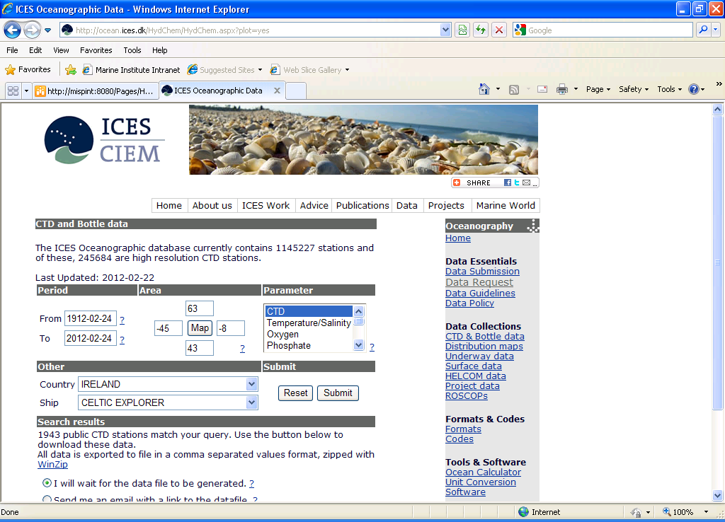

7. Keeping the Argo bibliography (http://www.argo.ucsd.edu/Bibliography.html) up to date and accurate is an important part of the Argo website. This document helps demonstrate the value of Argo and can possibly help countries when applying for continued Argo funding. We are almost to 1000 papers published using Argo data! So, please include a list of all papers published by scientists within your country in the past year using Argo data, including non-English publications.
Unfortunately, none that I am aware of.

8. I am also attaching a spreadsheet of the commitments table which I updated on January 18,2012 using the AIC website. Wow - Argo deployed a lot of floats this year - 877! I had to go back all the way to 2006 to find a year where more floats were deployed. Good job getting many of the backlogged floats into the water. Please correct any errors on float totals in the past year and send me an estimate of the expected number of deployments for 2012.
Ireland will deploy three Provor floats in the North Atlantic in summer 2012.

