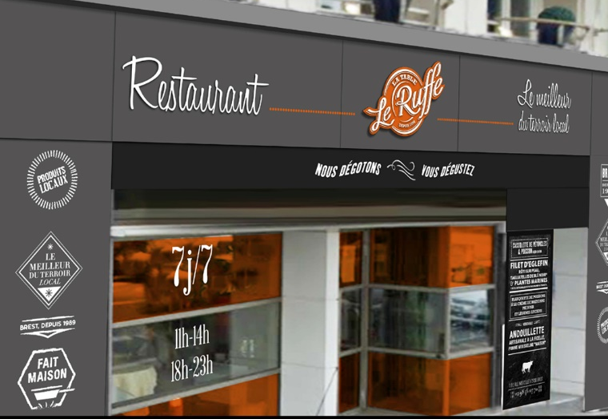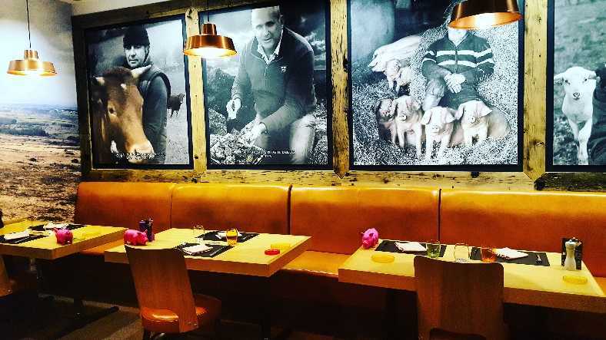
LE RUFFE Restaurant
1 BIS, RUE YVES COLLET
29200 BREST

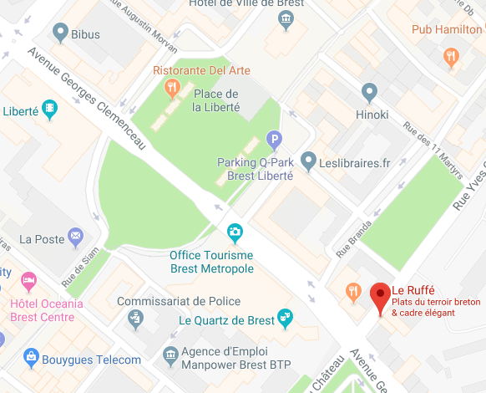
Informal restaurant with attention to fresh local products
(Seafood, meat, vegetables, etc…)

